Award In Digital Applications – D201 Using ICT

For this unit of work Edexcel will give you a project scenario. You will need to do some research on the topic set, and produce various documents as specified in the brief. You will then put all these documents into an eportfolio, which will be assessed by the exam board (Edexcel).

In order to practice the skills required for the set project, you will work through a sample project of a similar nature.

Resources to help you along the way:

Course Textbook:

D201: Using ICT The complete course book for the DiDA by P.M. Heathcote and R.S.U. Heathcote.

E-Learning tutors: DiDA web and intranet resources

D201 Student Resources – images, sounds, templates etc for completing the project. Your ICT teacher will show you how to access this information.

Project brief – The scenario

The Global Environment Association (GEA) is a charity dedicated to preserving the natural environment and plant and animal species in all parts of the world.

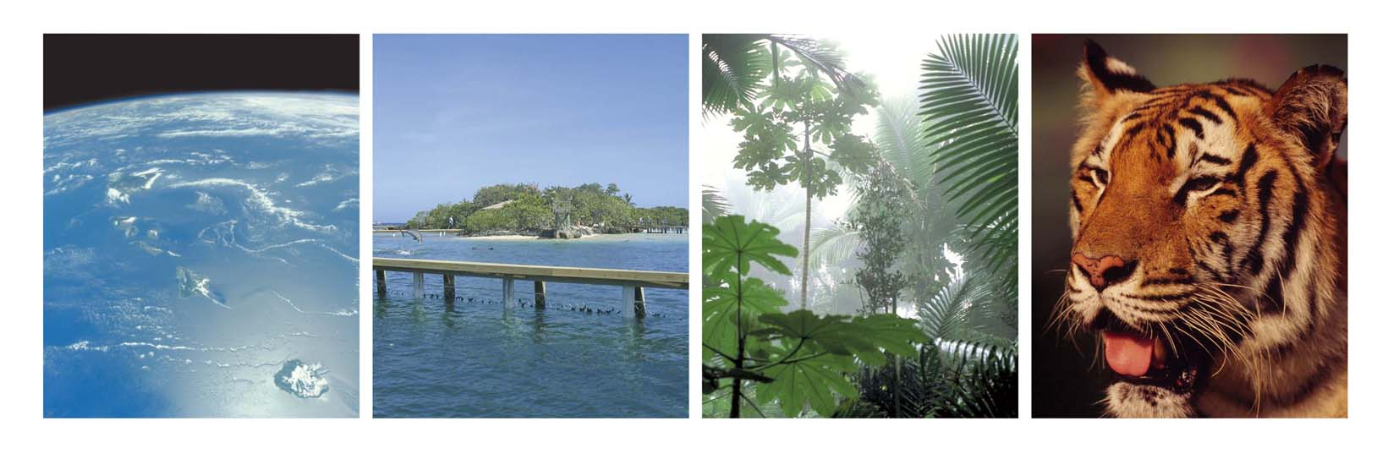
There are many threats to wildlife, which the GEA are working to reduce. These include:
- Climate change;
- Destruction of marine habitat, and over fishing;
- Deforestation;
- Illegal trade in animal products, such as tiger bones, ivory, and rhino horn.

What can you do about it?

The GEA has recruited volunteers in schools and colleges to help increase the awareness of the issues and raise funds to help with their work. You have volunteered to be the representative for your school.

You will use ICT for much of your work – for example:
- To find out how much people know about environmental issues and endangered species;
- To find out whether people care about species becoming extinct and are prepared to take action;
- To inform and persuade others of the value of the GEA’s work.

You will be creating posters, leaflets, surveys and presentations. It is vital when creating each of these that you remember who you are aiming it at. If you get it right, you will find that the publications you create will actually work in educating and persuading others.

Planning your project

For your eportfolio you must produce a detailed plan of how you will complete all the required tasks within the time allowed.

Before you start the plan:

- Read through the project brief – make sure that you understand it;
- Make a list of everything that you need to do;
- Decide how long you think each element is going to take;
- Decide on the order in which the tasks need to be done;
- Decide at what points you need to get feedback and to evaluate your work.

At regular intervals you must make sure that you are on schedule; if you are not, you must reschedule the remaining tasks into the time you have left to complete the project. Keep a record of changes made to your schedule.

For this trial project, some of the planning will be done for you. You will still need to keep a check on your progress.

The time allocated for the completion of the trial project is approximately 16 weeks. If you have 2 periods per week you will have 32 hours to work on this project. The trial project will be completed during the Autumn term and the first two weeks of January 06.

The tasks that you need to complete are all explained in more detail in the course textbook.

Here are the tasks that you must complete:

- Produce a plan listing individual tasks and estimated completion dates.
- Create an organised directory structure for your project files.
- Gather information for a leaflet about endangered species and what can be done to save them.
- Design and produce the leaflet.
- Produce a questionnaire for a survey on environmental issues.
- Design a spreadsheet to record the results.
- Use formulae to analyse the results, and produce charts.
- Present the results of the survey, to help GEA target their marketing more effectively.
- Create an interactive information point for display in the school to raise awareness of GEA’s work and to advertise a fundraising concert.
- Create a database of donors and import existing data.
- Design the data entry form for inputting new donors.
- Extract information from the database using queries.
- Design a report showing the names of donors and other details.
- Design a poster advertising the concert.
- Design a flyer advertising the concert.
- Write a letter to the band, thanking them for playing at the concert.
- Get feedback and evaluate the project.
- Create the eportfolio.

